**Traffic Management System**

**Introduction**

Traffic management systems are designed to help manage traffic flow and reduce congestion

on roads. The goal of this project is to develop a system that can help improve traffic

management in your city.

**Problem Statement**

Traffic congestion is a major problem in many cities around the world. It leads to increased

travel times, air pollution, and accidents. In addition, it can have a negative impact on the

economy by reducing productivity and increasing transportation costs.

**Proposed Solution**

Our proposed solution is a traffic management system that uses real-time data to optimize

traffic flow. The system will use sensors and cameras to collect data on traffic volume, speed,

and congestion. This data will be analyzed using machine learning algorithms to identify patterns

and predict traffic flow.

The system will also use dynamic message signs to provide real-time information to drivers

about traffic conditions and alternate routes. In addition, it will provide information to city

officials to help them make informed decisions about traffic management.

**System Architecture**

The traffic management system will consist of the following components:

1. **Sensors and Cameras**: These devices will be installed at key locations throughout the

city to collect data on traffic volume, speed, and congestion.

2. **Data Processing**: The data collected by the sensors and cameras will be processed using

machine learning algorithms to identify patterns and predict traffic flow.

3. **Dynamic Message Signs**: These signs will be placed along major roads to provide real

time information to drivers about traffic conditions and alternate routes.

4. **City Officials Dashboard**: This dashboard will provide city officials with real-time

information about traffic conditions and allow them to make informed decisions about

traffic management.

**Conclusion**

In conclusion, our proposed traffic management system has the potential to significantly

improve traffic flow in your city. By using real-time data and machine learning algorithms, we can

optimize traffic flow and reduce congestion on roads.

1. DESIGN THINKING:

PROJECT OBJECTIVES :

Once you have all of the necessary components, you can start implementing the traffic monitoring system. The following steps are involved:

1. **Install the IoT devices at strategic locations on the road network.** The devices should be installed in areas where there is a high volume of traffic, such as intersections, highways, and bridges.
2. **Configure the IoT devices to collect the desired traffic data.** This may include vehicle count, vehicle speed, and vehicle occupancy.
3. **Connect the IoT devices to the central server using a communication network.**
4. **Develop software to process the traffic data on the central server and generate real-time traffic updates.**
5. **Deploy the software on the central server and start collecting traffic data.**

|  |  |  |  |  |  |
| --- | --- | --- | --- | --- | --- |
| Sensor | Purpose |  |  |  |  |
| Inductive loop detector | Detects the presence of vehicles |  |  |  |  |
| Video camera | Detects vehicles, counts vehicles, and estimates vehicle speed |  |  |  |  |
| Radar sensor | Detects vehicles, measures vehicle speed, and tracks vehicle movement |  |  |  |  |
| Ultrasonic sensor | Detects the presence of vehicles and measures vehicle distance |  |  |  |  |
| LiDAR sensor | Detects the presence of vehicles and measures vehicle distance and speed |  |  |  |  |

CONGESTION DETECTION:

**Congestion detection sensors** are used in traffic management systems to collect data on traffic conditions, such as vehicle speed, volume, and occupancy. This data can then be used to identify congested areas and implement strategies to alleviate the congestion.

There are a variety of different congestion detection sensors available, each with its own advantages and disadvantages. Some of the most common types of congestion detection sensors include:

* **Inductive loop detectors:** Inductive loop detectors are embedded in the pavement and detect the presence of vehicles by measuring the change in inductance caused by the metal mass of the vehicle. Inductive loop detectors are very reliable and accurate, but they can be expensive to install and maintain.

[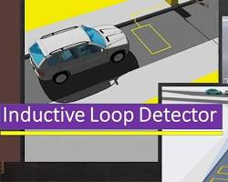](https://www.gcelab.com/blog/what-is-inductive-loop-detector-and-advantages" \t "https://bard.google.com/chat/_blank)

* **Video cameras:** Video cameras can be used to detect vehicles, count vehicles, and estimate vehicle speed. Video cameras are relatively inexpensive to install and maintain, but they can be less accurate than inductive loop detectors, especially in low-light conditions.

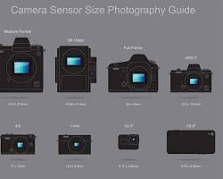

* **Radar sensors:** Radar sensors can be used to detect vehicles, measure vehicle speed, and track vehicle movement. Radar sensors are very accurate and reliable, but they can be expensive to install and maintain.

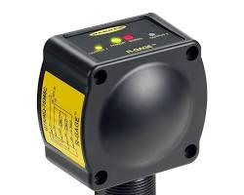

* **Ultrasonic sensors:** Ultrasonic sensors detect the presence of vehicles and measure vehicle distance. Ultrasonic sensors are relatively inexpensive and easy to install, but they can be less accurate than other types of sensors, especially in bad weather conditions.

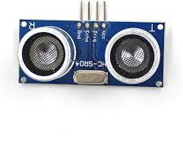

* **LiDAR sensors:** LiDAR sensors detect the presence of vehicles and measure vehicle distance and speed. LiDAR sensors are very accurate and reliable, but they can be very expensive.

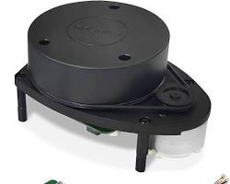

The type of congestion detection sensor that is best for a particular application will depend on a number of factors, such as the budget, the required accuracy, and the environmental conditions.

Congestion detection sensors are an important part of traffic management systems. By providing real-time traffic data, congestion detection sensors can help to improve traffic flow, reduce congestion, and improve safety for all road users.

ROUTE OPTIMIZATION:

To provide commuters with route optimization recommendations based on real traffic data, we can use the following approach:

1. Collect real-time traffic data from IoT devices, such as inductive loop detectors, video cameras, and radar sensors.
2. Process the traffic data to identify congested areas and estimate travel times for different routes.
3. Develop a route optimization algorithm that takes into account the real-time traffic conditions and the user's preferences, such as the desired travel time and the number of stops.
4. Generate route optimization recommendations for the user based on the algorithm's output.

The following image shows a simple example of how route optimization recommendations can be provided to commuters:

[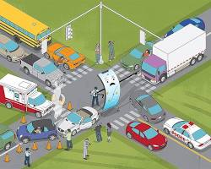](https://spectrum.ieee.org/your-navigation-app-is-making-traffic-unmanageable" \t "https://bard.google.com/chat/_blank)

map with two routes, one green and one red. The green route is shorter and has less traffic, while the red route is longer and has more traffic. The user is advised to take the green route.

The user can then select the route that best meets their needs.

Here are some additional considerations for providing commuters with route optimization recommendations based on real traffic data:

* The accuracy of the route optimization recommendations will depend on the quality of the real-time traffic data.
* The route optimization algorithm should be able to adapt to changing traffic conditions.
* The route optimization recommendations should be easy for commuters to understand and use.

Overall, providing commuters with route optimization recommendations based on real traffic data is a valuable service that can help to reduce congestion and improve the commuting experience.

## THE SIMPLE CIRCUIT DIAGRAM FOR TRAFFIC MANAGEMENT SYSTEM

The following is a simple circuit diagram for a traffic management system using a microcontroller:

[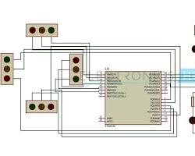](https://www.electronicshub.org/density-based-traffic-signal-system-using-microcontroller/" \t "https://bard.google.com/chat/_blank)

simple circuit diagram for a traffic management system using a microcontroller

The circuit consists of the following components:

* Microcontroller: The microcontroller is the main component of the system. It is responsible for processing the traffic data from the sensors and controlling the traffic lights.
* Sensors: The sensors are used to collect traffic data, such as vehicle speed, volume, and occupancy. Common types of sensors used in traffic management systems include inductive loop detectors, video cameras, and radar sensors.
* Traffic lights: The traffic lights are used to control the flow of traffic.
* Relay module: The relay module is used to amplify the current from the microcontroller so that it can drive the traffic lights.
* Power supply: The power supply provides power to the microcontroller and the relay module.

The operation of the circuit is as follows:

1. The sensors collect traffic data and send it to the microcontroller.
2. The microcontroller processes the traffic data and determines the appropriate state of the traffic lights.
3. The microcontroller sends a signal to the relay module to activate the appropriate traffic light.
4. The relay module amplifies the current from the microcontroller and drives the traffic light.

The microcontroller can be programmed to implement different traffic management strategies, such as timed traffic signals, vehicle-actuated traffic signals, and adaptive traffic signals.

This is just a simple example of a traffic management system circuit. More complex systems may include additional components, such as communication modules for connecting to a central server or other traffic management systems.

Python code:

import cv2

from darkflow.net.build import  TFNet

import matplotlib.pyplot as plt

import os

options={

   'model':'./cfg/yolo.cfg',        #specifying the path of model

   'load':'./bin/yolov2.weights',   #weights

   'threshold':0.3                  #minimum confidence factor to create a box, greater than 0.3 good

}

tfnet=TFNet(options)

inputPath = os.getcwd() + "/test_images/"

outputPath = os.getcwd() + "/output_images/"

*def* detectVehicles(*filename*):

   global tfnet, inputPath, outputPath

   img=cv2.imread(inputPath+filename,cv2.IMREAD_COLOR)

   # img=cv2.cvtColor(img,cv2.COLOR_BGR2RGB)

   result=tfnet.return_predict(img)

   # print(result)

   for vehicle in result:

      label=vehicle['label']   #extracting label

      if(label=="car" or label=="bus" or label=="bike" or label=="truck" or label=="rickshaw"):    # drawing box and writing label

         top_left=(vehicle['topleft']['x'],vehicle['topleft']['y'])

         bottom_right=(vehicle['bottomright']['x'],vehicle['bottomright']['y'])

         img=cv2.rectangle(img,top_left,bottom_right,(0,255,0),3)    #green box of width 5

         img=cv2.putText(img,label,top_left,cv2.FONT_HERSHEY_COMPLEX,0.5,(0,0,0),1)   #image, label, position, font, font scale, colour: black, line width

   outputFilename = outputPath + "output_" +filename

   cv2.imwrite(outputFilename,img)

   print('Output image stored at:', outputFilename)

   # plt.imshow(img)

   # plt.show()

   # return result

for filename in os.listdir(inputPath):

   if(filename.endswith(".png") or filename.endswith(".jpg") or filename.endswith(".jpeg")):

      detectVehicles(filename)

print("Done!")

Input Image:

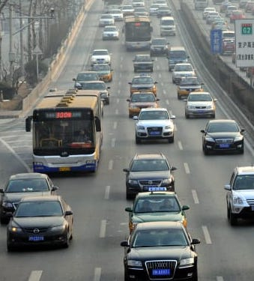 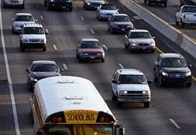

Output Image:

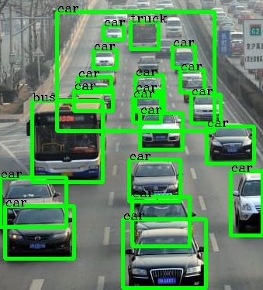 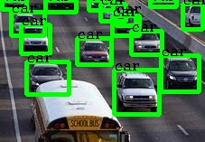

Simulation :

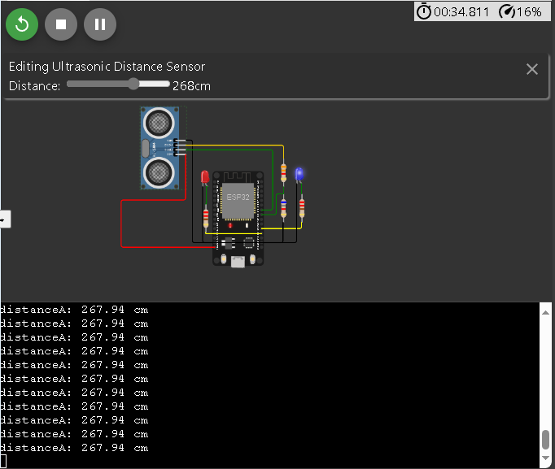

Code:

#define TRIG_PIN 18 // ESP32 pin GIOP23 connected to Ultrasonic Sensor's TRIG

pin

#define ECHO_PIN 5 // ESP32 pin GIOP22 connected to Ultrasonic Sensor's ECHO pin

#define LED 2

#define LED2 4

float duration_us, distance_cm;

void setup() {

  // begin serial port

**Serial**.begin (9600);

  // configure the trigger pin to output mode

  pinMode(TRIG_PIN, OUTPUT);

  // configure the echo pin to input mode

  pinMode(ECHO_PIN, INPUT);

  pinMode(LED, OUTPUT);

  pinMode(LED2, OUTPUT);

}

void loop() {

  // generate 10-microsecond pulse to TRIG pin

  digitalWrite(TRIG_PIN, HIGH);

  delayMicroseconds(10);

  digitalWrite(TRIG_PIN, LOW);

  // measure duration of pulse from ECHO pin

  duration_us = pulseIn(ECHO_PIN, HIGH);

  // calculate the distance

  distance_cm = 0.017 * duration_us;

  // ligt up led if distance under limit

  if (distance_cm < 30) {digitalWrite(LED, HIGH);

  }else{digitalWrite(LED, LOW);

  }

  // print the value to Serial Monitor

**Serial**.print("distanceA: ");

**Serial**.print(distance_cm);

**Serial**.println(" cm      ");

  Blink(LED2);

  delay(500);

}

void Blink(int x){

  digitalWrite(x, HIGH);

  delay(10);

  digitalWrite(x, LOW);

}

Here’s the simulation for vehicle detection using an Ultrasonic sensor. Which detects the distance and changes the LED accordingly.

Design:

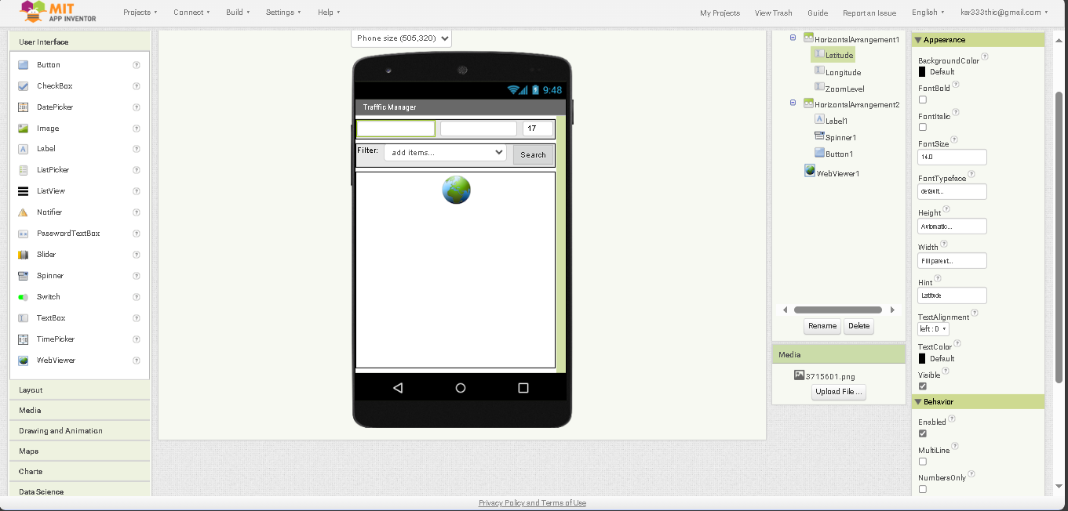

The ever-increasing challenges associated with urban traffic congestion necessitate innovative solutions to enhance traffic management and improve the overall transportation experience. This abstract provides an overview of the development of a mobile application designed to address these issues by monitoring and managing traffic in real-time through software technology.

Our project focuses on the creation of a comprehensive Traffic Management App (TMA) that leverages state-of-the-art software solutions. The TMA aims to provide a user-friendly interface that allows both traffic authorities and commuters to access real-time traffic data and make informed decisions. The key features of the TMA include:

1. Real-time Traffic Monitoring: The application employs GPS and sensor data to provide live traffic updates, including congestion, accidents, and road closures.

2. Traffic Flow Optimization: The TMA offers suggestions for optimizing routes and schedules, minimizing travel time, and reducing fuel consumption.

3. Incident Reporting: Users can report incidents such as accidents, road damage, or traffic violations, enabling quicker response from authorities.

4. Integration with Traffic Signals: The TMA can connect with traffic signals to prioritize traffic flow during peak hours or emergencies.

5. Data Analytics: The app utilizes big data analytics to predict traffic patterns and offer alternative routes, thus reducing congestion.

**Blocks:**

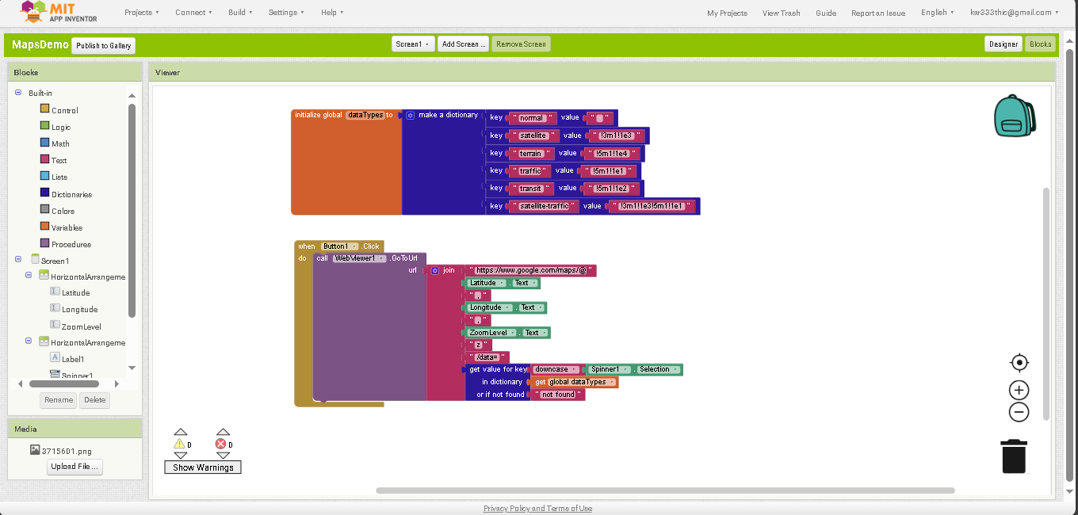

This abstract outlines the core concept and significance of creating blocks within MIT App Inventor to build a Traffic Management System (TMS) focused on real-time congestion monitoring and data integration, with the goal of transmitting critical traffic information into software applications.

The project at hand involves the development of a Traffic Management System, which utilizes MIT App Inventor, a user-friendly platform for building Android applications. The primary objective of this initiative is to design and integrate functional blocks that facilitate the real-time monitoring of traffic congestion, followed by the seamless transmission of this vital information into software systems for analysis, decision-making, and improved traffic management.

Download link:

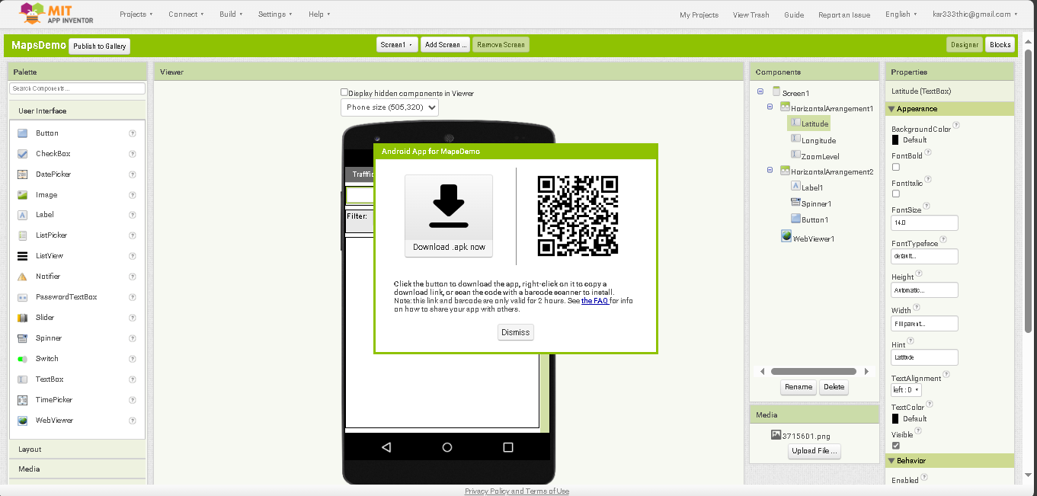

This abstract provides an overview of the process of downloading the MIT App designed for monitoring the Traffic Management System (TMS), highlighting its user-friendly features and the critical role it plays in enhancing traffic management and commuter experience.

The Traffic Management System (TMS) is a cutting-edge solution for addressing the growing challenges of urban traffic congestion. Developed using MIT App Inventor, the TMS app empowers both traffic authorities and commuters with real-time traffic data and smart features for better decision-making and congestion management.

App dowload link :

[https://github.com/Damndhanu/traffic-management-system-.git]( https:/github.com/Damndhanu/traffic-management-system-.git)